A Multi-Modal Approach To Human Action Anticipation
Anonymous ICME Submission

Abstract—This paper proposes a simple modification that can be made to existing human skeleton action recognition models to improve action classification accuracy and human action anticipation capability. We propose a method of extracting human early visual motion cues by sampling windows of optical flow surrounding skeleton keypoints in image space. We have titled this Pose-guided Optical Flow Feature methodology, PoseOFF. PoseOFF samples optical flow from windows anchored at human pose keypoints, therebyembedding visual motion information in the learning process , enabling human action in fewer observed frames. With the addition of a lightweight embedding layer to learn windows of optical flow extracted with PoseOFF, we demonstrate its effectiveness with three state of the art skeleton-based action recognition models (InfoGCN++, MS-G3D, ST-GCN++). Specifically, our result show improved outcomes with respect to action classification accuracy, and latency (i.e., fewer observed frames for prediction) on three human action recognition datasets ( NTU RGB+D 60, NTU RGB+D 120 skeleton datasets and the UCF-101 RGB). Evaluation of the models on an RGB only dataset demonstrates the broad applications of data extraction and embedding method.
Index Terms—Human Action Recognition, Online Action Recognition, Human Motion Prediction, Multi-modal Media Computing

- Introduction
Human action prediction is a common task in computer vision that aims to predict actions in video data. Where such predictions are required quickly and as part of an interaction loop with humans, the problem becomes one of action anticipation, with the aim to achieve accurate action prediction in as few observed frames as possible. Example applications include human-robot teaming [18], pedestrian avoidance [12], abnormal activity detection in surveillance [13] and fall detection in aged care settings, among others., The task of action anticipation thus focuses on the accuracy, speed and frame latency of action classification [6]. =
[Short summary of optical flow, what it tells us]
Early visual motion cues offer predictive cues during human move-ment or action [CITE]. In primate brains, these motion cues are perceived at early stages of visual processing to prime other centres of the brain (for example, the pre-motor cor-tex) [10]. This sensitivity to motion comes from the human vision system’s use of optical flow - the perceived movement of light patterns projecting onto the eye. In the analysis of human actions, these early motion cues are generally exhibited as image motion located around specific points of interest on the human body [CITE].
Human skeleton keypoints are 2D or 3D locations of major human body joints extracted from images or videos. These skeleton keypoints provide meaningful and succinct informa-tion about human actions. However, skeleton keypoints contain information only about position and movement of humans. While this
allows action recognition algorithms to learn from data that is free from environmental noise, such as dynamic lighting conditions and background clutter, s
keleton-only approaches fail to capture relationships between limbs, and do not cope well with limb occlusion. Dedicated skeleton action recognition datasets often require human ac-tions to be captured from multiple angles using multiple RGB-D sensors to produce reliable skeleton information [14] [7]. For actions with similar body motions, skeleton-only learning approaches fail to capture contextual features that may differ-entiate the actions, such as actions like “put on backpack” and “put on jacket”.
RGB-only approaches to human action recognition must contend with large amounts of calculations needed to process video data. Complex environments, such as outdoor settings or shifting camera perspectives, present challenges for RGB-only models in capturing robust human action features [17]. RGB-only models designed to perform human early action recognition suffer when distinguishing intra-class differences and inter-class similarities.
To address these challenges, we propose a method of embedding localised spatio-temporal features extracted from keypint-anchored windows of option flowin existing skeleton-based action recognition models. Our Pose-guided Optical Flow Feature extraction method (PoseOFF) involves the strategic sampling of windows of optical flow surrounding human skeleton keypoints. Optical flow can provide more nuanced information than the simple displacement vectors of skeleton keypoints. A simple embedding layer integrated in three state-of-the-art skeleton-based action recognition algorithms shows an improvement in classification accuracy and action antici-pation.
The main contributions of this work are:
- PoseOFF, a novel feature embedding derived from optical flow in order to anticipate human action from early visual motion cues.
- A simple embedding layer that can be easily implemented in existing skeleton-based action recognition models to learn windows of optical flow.
- An evaluation of the performance of three state-of-the-art skeleton-based action recognition models with and without the PoseOFF embeddings.
- Demonstration of an enhanced action anticipation ability of skeleton-based action recognition models with the use of PoseOFF features.

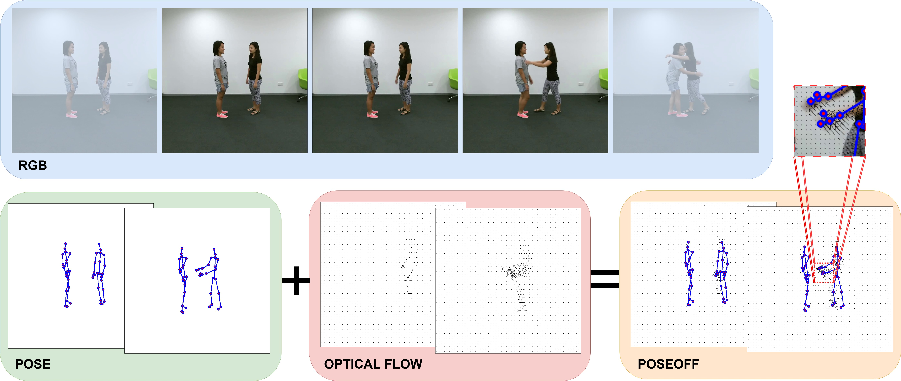

Fig. 1. Extraction method for sampling windows of optical flow surrounding human pose keypoints. From the RGB videos, both human skeleton keypoints (pose) and optical flow are extracted. Windows of optical flow vectors are sampled surrounding each human pose keypoint to generate Pose-guided Optical Flow Feautres (PoseOFF). This PoseOFF data includes both joint coordinates in (x,y,z) space, as well as 25 (u,v) vectors representing the window of optical flow sampled surrounding each pose keypoint.

- Related work
Skeleton keypoints that are designed to represent human pose keypoints can be depicted as graphs, with graph nodes and edges representing human joints and bones respectively. This compact representation lends itself well to machine learning techniques based in graph theory, such as graph convolutional networks (GCNs) [5].
A GCN proposed by Duan et al. [4], ST-GCN++, achieved competitive performance on skeleton-based action recognition datasets without the need for complicated attention mecha-nisms to model temporal dynamics. ST-GCN++ was designed to provide a baseline for future skeleton-based action recogni-tion models. Liu et al. [8] designed MS-G3D, a skeleton-based action recognition model utilising spatial-temporal graph con-volution modules, to pass information across different graph scales.
Existing human-action recognition models must capture the entire action sequence in order to make predictions, which may present latency issues for real-time applications such as human-robot interaction. Chi et al. [2] incorporated a Neural Ordinary Differential Equations module into a skeleton-based action recognition model to model future skeleton states. Their model, InfoGCN++, was able to classify human actions in skeleton datasets with fewer observed frames than existing skeleton-based action recognition models.
Multi-modal approaches to human action recognition are also commonly applied. For example, Cai et al. [1] proposed a two-stream architecture for hockey action recognition that utilised both optical flow and human poses. The inclusion of an optical flow stream increased hockey action classification accuracy by 10%.
Using this motion information [CITE] demonstrated that human actions could be anticipated with fewer frames that using standard RGB videos. [CONT]
- METHOD
We propose a novel feature extraction method designed to be easily integrated within existing state of the art skeleton-based action recognition models. The feature extrac-tion framework, PoseOFF, is designed to sample an capture early visual motion cues in order to support anticipatory action prediction. By embedding these early motion cues as learnable features in skeleton-based action recognition models, we aim to show that the features obtained through the PoseOFF extraction method can provide these state-of-the-art models greater action anticipation ability without sacrificing action classification accuracy.
- PoseOFF
Pose-guided Optical Flow Features, PoseOFF, is a general term for the method of sampling windows of optical flow surrounding human-pose keypoints. We have chosen to sample optical flow surrounding human-pose keypoints as these are areas in videos of humans where motion relating to human actions take place (the human body). Specifically, optical flow surrounding human pose keypoints was chosen as a way to embed human early visual motion cue information into existing skeleton action recognition models. An overview of the data extraction approach is depicted in Figure 1.

.
PoseOFF sampling provides a considerably more data ef-ficient method of embedding optical flow information that

TABLE I
Classification accuracy for all models trained and tested on the NTU-RGB+D (NTU), NTU-RGB+D120 (NTU120) and UCF-101
DATASETS - JOINT STREAM ONLY.

 |  | NTU |  | NTU120 |  | UCF-101
 |  | CS | CV | CSub | CSet | 1 | 2 | 3
InfoGCN++ | Base | 83.52%  88.89% | 91.38%  93.68% | 75.92%  82.70% | 77.61%  83.70% | 59.21%  62.81% | 57.82%  62.54% | 58.90%  62.84%
 | PoseOFF
MS-G3D | Base | 87.40%  89.95% | 93.43%  94.12% | 76.24%  83.22% | 78.75%  85.49% | 61.39%  68.84% | 62.02%  69.88% | 63.45%  66.36%
 | PoseOFF
ST-GCN++ | Base | 84.78%  88.88% | 90.85%  93.70% | 76.54%  82.36% | 76.40%  85.00% | 47.37%  58.27% | 47.96%  60.13% | 46.86%  58.61%
 | PoseOFF

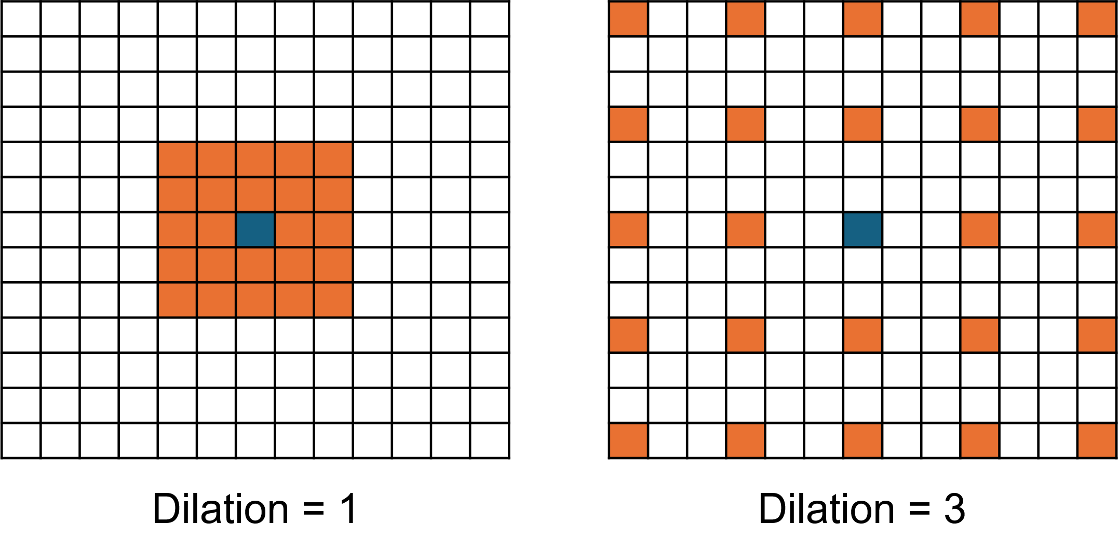
skeleton joint stream only. Each model was trained on full observations of input sequences and tested using masking of test sequences at 10% observation ratios. [Maybe an explainer of what observation ratio means?..] We used the temporal padding methods outlined in [2], [8], and [4] to pad the partially observed sequences to the frame length for each model’s input.

Fig. 2. Example of a 5×5 window of flow field sampling with dilation 1 (left) and dilation 3 (right). The grid represents the vector field of optical flow, with orange cells representing vectors sampled to embed as additional learnable features. The blue cell in the centre is the optical flow vector aligning with the pixel coordinates of the human pose keypoint around which the optical flow window is being sampled.

training a neural network to learn from the entire flow field. [Comparison of data size comparisons -¿ skeletons alone -¿ PoseOFF -¿ skeletons + full flow field]
Optical flow provides richer information than joint displace-ment vectors alone. Windows of optical flow can contain nuanced information about the rotation or deformation of surfaces surrounding keypoints, where displacement vectors only indicate joint positional translation [1].
- Skeleton-based Action Recognition Models
To demonstrate the applicability and effectiveness of PoseOFF, we modify three state-of-the-art skeleton-keypoint action recognition models to incorporate learnable early visual motion cues. The embedding layer of each model was modified to include a simple CNN designed to learn the features present in the windows of optical. The CNN consisted of two convolutional layers separated by activation layers, pooling and a linear layer. The output of these layers was concatenated with the original skeleton keypoints coordinates as additional channels in the skeleton graph.
The models tested using this methodology were In-foGCN++ [2], MS-G3D [8], and ST-GCN++ [4]. The models
were trained using the hyperparametes defined by the mod-els’ authors, with settings as close to those provided in the respective papers.
- Experiments
- Experimental Settings
All models were implemented in Python using the PyTorch learning framework [11]. Optical flow was extracted using the PyTorch implementation of the RAFT algorithm [16]. When skeleton keypoints are not available, we extract human pose keypoints using the YOLO-POSE Large model [9].
Datasets. The models were trained and evaluated on three different datsets; the NTU RGB+D 60 dataset [14],NTU RGB+D 120 dataset [7] and the UCF-101 dataset [15].
The NTU RGB+D 60 and NTU RGB+D 120 datasets consist of images obtained from three separate Microsoft Kinect v2 sensors, with ground truth 3D human skeleton data for every sample. These datasets contain RGB videos, depth sequences, skeleton data (3D locations of 25 major body joints), and infrated frames. Samples in these datasets are assigned one class label from a possible 60 or 120 classes respectively.
The UCF-101 dataset is composed of human actions within videos collected “in the wild”. This is an RGB only video dataset, and both the human skeleton keypoints and optical flow were estimated using the methods outlined above.
Evaluation Metrics. For the task of action classification, model performance was measured using the classification accuracy; that is, the percentage of samples that the models were able to predict the correct class label of after observing the full action sequence. For the task of action anticipation, both the classification accuracy at each given observation ratio and the Area Under the Curve (AUC) are reported. The AUC is a measure of the model’s performance across all evaluated observation ratios, and is calculated as:
� Acc_{obs}

The PoseOFF extraction method utilises human skeleton
joints as locations in image space from which to extract
AUC =

Nobs

windows of optical flow. For this reason, the results presented in this paper are models trained and evaluated using the
where Acc_{obs} is the accuracy at a given observation ratio, obs, and N_{obs} is the number of evaluated observation ratios.

- Action Classification
All models were trained and evaluated using full observa-tions of the action sequences. The PoseOFF data was learned using a simple CNN layer added to each model’s embedding layer. The flow windows for the NTU-RGB+D and NTU-RGB+D120 models were extracted using dilation 3. The flow windows for the UCF-101 dataset were extracted using dilation 1.
The results presented in Table I demonstrate that the im-plementation of PoseOFF as additional learnable embeddings improves model performance on the datasets tested. The optical flow features provide additional learnable information. We believe that this demonstrates the generalisability of the PoseOFF data extraction methodology.
The classification accuracy results for the UCF-101 dataset shows the most varied results between the models. This dataset is RGB only, containing human actions from videos “in the wild”. No depth data or skeleton poses accompany the dataset. The poses extracted using YOLO-POSE Large[9] are generally less accurate or precise than those included in the NTU RGB+D datasets. The models trained on data obtained using PoseOFF showed considerable improvements in classification accuracy across all datasets tested.
The RGB only dataset is a good test for the application of PoseOFF features in real world applications. CONT
- Action Anticipation
To test the effectiveness of the learnable features present in PoseOFF data, we evaluated each model at different observa-tion ratios of the input sequence. The models evaluated were trained on 100% observation ratio and were evaluated at 10% observation ratio intervals. The InfoGCN++ model produces an action class prediction for every frame of the input sequence (64 frame input), so the observation ratio interval evaluations were not necessary for this model. These results are presented in 3 and 4.
These experiments were designed to test whether PoseOFF effectively extracts human early visual motion cue informa-tion. Additionally, we were seeking to understand the role of human early visual motion cues in providing standard human skeleton action recognition models the ability to anticipate human actions.
The action anticipation results are an indication that the embedding of the features extracted with the PoseOFF method are able to anticipate the action happening in the videos more accurately, and with fewer frames. The gray dotted lines in these graphs is used to indicate the highest performance of the base model, in order to compare it’s performance with the PoseOFF embedded versions of the models.
The action anticipation results on the NTU RGB+D 60 dataset, shown in Figure 3, show that all models are able to predict the action taking place with fewer frames. For the ST-GCN++ and MS-G3D models, the PoseOFF embedded version of the model only needs to observe 80% of the entire action sequence to achieve the same performance as the base model at 100% observation ratio. At lower observation
ratios, the ST-GCN++ base model is able to predict the action more accurately than the PoseOFF embedded model. For InfoGCN++, which was specifically designed for the task of action anticipation, the PoseOFF embedded version of the model needs to only see approximately half of the input sequence to achieve the same performance as the base model at 100% observation ratio.
The action anticipation results on the UCF-101 dataset, shown in Figure 4, highlights the fact that PoseOFF embed-ded models are much stronger at the task of human action anticipation.
These results demonstrate that out method is able to increase the overall performance of models on noisy, and more realistic datasets.
The modifications made to the skeleton action recognition models were only in the first layers of the model, and did not significantly alter inner workings of the models. These results demonstrate the effectiveness of data extracted using the PoseOFF method. We believe that the data produced from the PoseOFF extraction method can be easily implemented in any skeleton-based action recognition model to improve the model’s action recognition and anticipation ability.
Existing skeleton-based action recognition models can be easily modified in order to learn features extracted with PoseOFF. This can improve the model performance for both human action classification and action anticipation.
- Conclusion
We have demonstrated that the embedding of human early visual motion cues into established skeleton based human action recognition can improve the action classification and action anticipation accuracy. We have also shown that .....
The implementation of PoseOFF into existing skeleton-based action recognition models requires only a minor modi-fication to the model’s embedding layer. PoseOFF presents a considerably more data efficient method of embedding this nuanced human early visual motion cue information into existing models.
In this work, PoseOFF was extracted with a fixed optical flow window sampling dilation. For the NTU-RGB+D and NTU-RGB+D 120 datasets, this flow sampling dilation was fixed to 3 pixels (d = 3), and for the UCF-101 dataset, there was no dilation (d = 1). In future work, we will explore the effects of a dynamic sampling dilation. This dilation factor could vary with quantities such as the apparent size of the human skeleton with respect to the frame size, or a skeleton keypoint’s distance from the camera.
References
- Zixi Cai et al. “Temporal Hockey Action Recognition via Pose and Optical Flows”. In: Proceedings of the IEEE/CVF Conference on Computer Vision and Pattern Recognition Workshops. 2019. URL: https://openaccess. thecvf . com / contentCVPRW2019 / html / CVSports / CaiTemporalHockeyActionRecognitionviaPose andOpticalFlowsCVPRW2019paper.html (visited on 10/25/2024).

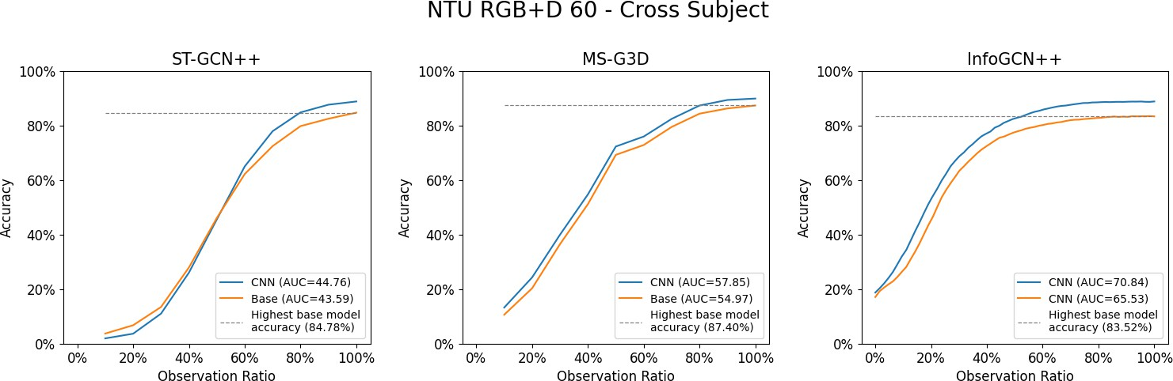

Fig. 3. Models trained using 100% observation ratios, evaluated at 10% observation ratio intervals on the NTU RGB+D 60 dataset, Cross Subject evaluation. The Area Under the Curve (AUC) is reported for each model in the sub figure labels.
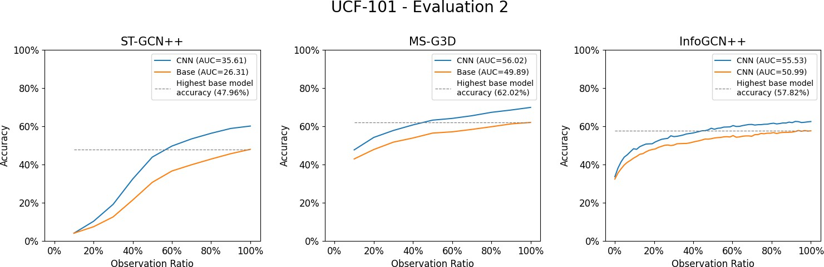

Fig. 4. Models trained using 100% observation ratios, evaluated at 10% observation ratio intervals on the UCF-101 evaluation 2. The Area Under the Curve (AUC) is reported for each model in the sub figure labels.

- Seunggeun Chi et al. InfoGCN++: Learning Repre-sentation by Predicting the Future for Online Human Skeleton-based Action Recognition. Oct. 2023. DOI: 10. 48550 / arXiv. 2310 . 10547. arXiv: 2310 . 10547 [cs].
URL: http : / / arxiv . org / abs / 2310 . 10547 (visited on
11/29/2024).
- “Deep Learning for Vision-based Fall Detection Sys-tem: Enhanced Optical Dynamic Flow”. In: (). DOI: 10.1111/coin.12428. URL: https://onlinelibrary.wiley. com/doi/10.1111/coin.12428 (visited on 11/15/2023).
- Haodong Duan et al. PYSKL: Towards Good Practices for Skeleton Action Recognition. May 2022. DOI: 10. 48550 / arXiv. 2205 . 09443. arXiv: 2205 . 09443 [cs].
URL: http : / / arxiv . org / abs / 2205 . 09443 (visited on
10/16/2025).
- M. Gori, G. Monfardini, and F. Scarselli. “A New Model for Learning in Graph Domains”. In: Proceed-ings. 2005 IEEE International Joint Conference on Neural Networks, 2005. Vol. 2. July 2005, 729–734 vol.
2. DOI: 10 . 1109 / IJCNN . 2005 . 1555942. URL: https :
/ / ieeexplore . ieee . org / document / 1555942 (visited on 03/16/2025).
- Bolin Lai et al. Human Action Anticipation: A Survey. Oct. 2024. DOI: 10.48550/arXiv.2410.14045. arXiv:
2410 . 14045 [cs]. URL: http : / / arxiv. org / abs / 2410 . 14045 (visited on 12/30/2024).
- Jun Liu et al. “NTU RGB+D 120: A Large-Scale Benchmark for 3D Human Activity Understanding”. In: IEEE Transactions on Pattern Analysis and Machine Intelligence 42.10 (Oct. 2020), pp. 2684–2701. ISSN:
0162-8828, 2160-9292, 1939-3539. DOI: 10 . 1109 / TPAMI.2019.2916873. arXiv: 1905.04757 [cs]. URL:
http://arxiv.org/abs/1905.04757 (visited on 01/24/2025).
- Ziyu Liu et al. Disentangling and Unifying Graph Convolutions for Skeleton-Based Action Recognition. May 2020. arXiv: 2003.14111 [cs]. URL: http://arxiv. org/abs/2003.14111 (visited on 08/12/2024).
- Debapriya Maji et al. YOLO-Pose: Enhancing YOLO for Multi Person Pose Estimation Using Object Keypoint Similarity Loss. Apr. 2022. DOI: 10.48550/arXiv.2204. 06806. arXiv: 2204.06806 [cs]. URL: http://arxiv.org/ abs/2204.06806 (visited on 04/18/2025).
- Hiu Mei Chow and Miriam Spering. “Eye Movements during Optic Flow Perception”. In: Vision Research 204 (Mar. 2023), p. 108164. ISSN: 00426989. DOI: 10 .
1016/j.visres.2022.108164. URL: https://linkinghub. elsevier.com/retrieve/pii/S0042698922001705 (visited on 03/07/2024).

- Adam Paszke et al. “PyTorch: An Imperative Style, High-Performance Deep Learning Library”. In: ().
- Amir Rasouli, Iuliia Kotseruba, and John K. Tsotsos. Pedestrian Action Anticipation Using Contextual Fea-ture Fusion in Stacked RNNs. May 2020. DOI: 10 . 48550 / arXiv. 2005 . 06582. arXiv: 2005 . 06582 [cs].
URL: http : / / arxiv . org / abs / 2005 . 06582 (visited on
02/13/2025).
- M. S. Ryoo. “Human Activity Prediction: Early Recog-nition of Ongoing Activities from Streaming Videos”. In: 2011 International Conference on Computer Vision. Nov. 2011, pp. 1036–1043. DOI: 10.1109/ICCV.2011.
6126349. URL: https : / / ieeexplore . ieee . org / abstract / document/6126349 (visited on 02/14/2025).
- Amir Shahroudy et al. “NTU RGB+D: A Large Scale Dataset for 3D Human Activity Analysis”. In: 2016 IEEE Conference on Computer Vision and Pattern Recognition (CVPR). Las Vegas, NV, USA: IEEE, June 2016, pp. 1010–1019. ISBN: 978-1-4673-8851-1. DOI:
10.1109/CVPR.2016.115. URL: http://ieeexplore.ieee. org/document/7780484/ (visited on 01/24/2025).
- Khurram Soomro, Amir Roshan Zamir, and Mubarak Shah. “UCF101: A Dataset of 101 Human Actions Classes from Videos in the Wild”. In: arXiv preprint arXiv:1212.0402 (2012). arXiv: 1212.0402.
- Zachary Teed and Jia Deng. RAFT: Recurrent All-Pairs Field Transforms for Optical Flow. Aug. 2020. DOI: 10.48550/arXiv.2003.12039. arXiv: 2003.12039 [cs].
URL: http : / / arxiv . org / abs / 2003 . 12039 (visited on
04/02/2025).
- Jiang wang et al. Cross-View Action Modeling, Learning and Recognition. May 2014. DOI: 10.48550/arXiv.1405. 2941. arXiv: 1405.2941 [cs]. URL: http://arxiv.org/ abs/1405.2941 (visited on 04/15/2025).
- Jiahui Yu et al. “A Multi-sensor Gesture Interaction System for Human-robot Cooperation”. In: ICNSC 2021
- 18th IEEE International Conference on Networking, Sensing and Control: Industry 4.0 and AI. Institute of Electrical and Electronics Engineers Inc., 2021. ISBN: 978-1-6654-4048-6. DOI: 10.1109/ICNSC52481.2021.
9702166.

